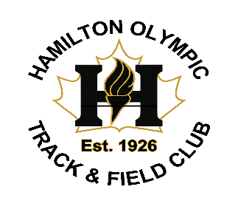
Dear Sponsor/Donor;
The Hamilton Olympic Club is heading into its’ 100th year of operation as an amateur Athletics club. The Hamilton Olympic Club is the oldest Athletics club operating in Canada. The Hamilton Olympic Club has served athletes young and old in developing their skills and reaching their dreams throughout the Greater Hamilton area since its inception in 1926.

Some of our former Hamilton Olympic Club athletes represented Canada at the Olympics; Ray Lewis the first Canadian-born black Olympic medalist at the 1932 Los Angeles Olympics in the 4x400m Relay earning a Bronze medal, Phil Edwards the “Man of Bronze” and Nancy Lewington 1960 Rome Olympics 100m sprints are among a few.

The club has hosted Olympic Trials, International Children’s Games, Royal Legion Nationals and small local meets. We have supported major area events; the Around the Bay Road race and the 91st Highlanders Hamilton Spectator Indoor Games. The Hamilton Olympic Club’s first president Melville Marks “Bobby” Robinson along with Robert Kerr, founded the British Empire Games in 1930 now known as the Commonwealth Games.

Our mission with this 100th anniversary celebration is to celebrate the past and build the foundation of our future. In order to commemorate the extensive history of the Hamilton Olympic Club we are recording its history through a commemorative book and video documentary project spanning the 100-year existence of the club. This historical endeavour will not only capture the grand history of the oldest Amateur Sport Club in Canada but the proceeds will help the club to continue its program offering opportunity to youth to continue to train and compete in the Greater Hamilton area.

In order to complete this endeavour, the club is looking for financial support from donors in the form of sponsorship advertising. Donors can support this project through the purchase of sponsor package(s) described below.

Thanking you in advance for your support it is much appreciated.

Sincerely,

Marcello Campanaro
President
Hamilton Olympic Club

HOC 100th Anniversary Sponsorship Packages
Double Platinum Level-$5000.00
- Track & Field Meets
- Sponsors banner posted at Club run Meet Series for 2026
- Company name/logo will appear weekly on social media for sponsor recognition for the 2026 season
- HOC 100 Gala
- Company table at HOC 100 Gala for 10 people
- Company name/logo on printed promotional material for the event
- Company recognition during event-announcement- on screen- in print
- Full page ad in HOC 100 Commemorative Book (location of ad in book-with Platinum sponsor location)
- Recognition of Sponsor in the Video Documentary
- Banner ad on HOC website until the end Dec 31, 2027
- HOC Awards Night 2026
- Company name/logo will appear on promotional material for the event (Social Media)
- Company recognition during event
- Sponsor banner on display.
Platinum Level $2,500.00
- Track & Field Meets
-Sponsors banner posted at Club run Meet Series for 2026
-Company name/logo will appear weekly on social media for sponsor recognition for the 2026 season
- HOC 100 Gala
-Company table at HOC 100 Gala for 4 people
-Company name/logo on printed promotional material for the event
-Company recognition during event-announcement- on screen- in print
-Full page ad in HOC 100 Commemorative Book (location of ad in book-with Platinum sponsor location)
-Recognition of Sponsor in the Video Documentary
-Banner ad on HOC website until the end Dec 31, 2027
- HOC Awards Night 2026
-Company name/logo will appear on promotional material for the event (Social Media)
-Company recognition during event
-Sponsor banner on display
Diamond Level $1,500.00
- Track & Field Meets
-Sponsors banner posted at Club run Meet Series for 2026
-Company name/logo will appear weekly on social media for sponsor recognition for the 2026 season
- HOC 100 Gala
-Two (2) tickets to HOC 100 Gala
-Company recognition during event-in print-on screen
-Full page ad in HOC 100 Commemorative Book
-Banner ad on HOC website until the end Dec 31, 2027
- Awards Night 2026
-Company recognition during event in print- on screen
Gold Level $1,000.00
- Full page ad in HOC 100 Commemorative Book
- Banner ad on HOC website until the end Dec 31, 2027
- Company recognition during event-announcement- on screen- in print
Silver Level $550.00
- Half page ad in HOC 100 Commemorative Book
- Recognition on HOC website until the end Dec 31, 2027
- Company recognition during event-announcement- on screen- in print
Bronze Level $300.00
- Quarter page ad in HOC 100 Commemorative Book
- Recognition on HOC website until the end Dec 31, 2027
- Company recognition during event-announcement- on screen- in print
***A digitized copy of the book will be added to our website, your add will be on our website indefinitely.

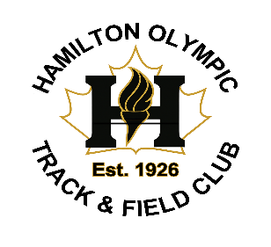
Thank you for supporting the Hamilton Olympic Club 100th Anniversary Project. Please complete the form with your pertinent information and sponsorship commitment.
Go to the Link below to complete
https://docs.google.com/forms/d/e/1FAIpQLScRg52MDAeFgY1M7XaV2M48JU1rMz1EvwmJ8JauND_C11cVsA/viewform?usp=publish-editor
First Name:
Last Name:
Organization Name:
Address:
City:
Province:
Country:
Phone Number:
Email Address:
Sponsorship Package Commitment; Please Select from below.
- Double Platinum Package $5000.00
- Platinum Package $2500.00
- Diamond Package $1500.00
- Gold Package $1000.00
- Silver Package $550.00
- Bronze Package $300.00
Select Package Commitment:
- Payment can be made through e-transfer expense.hoc@gmail.com or by cheque made out to Hamilton Olympic Club @133 Middletown Rd. Dundas ON. L9H5E1

- Please send any LOGOS to: hoc100yearbook@gmail.com
Once submitted, a member of our committee will follow up with you.

